1. Write the business rule(s) that govern the relationship between AGENT and CUSTOMER. Considering the information in each table, agent, through agent code can appear in the customer table. However, each customer correlates with one agent. The business rule can be written as such, every agent can have numerous customers, and every customer has a single agent.
2. Given the business rule(s) you wrote in Problem 1, create the basic Crow’s Foot ERD.



1. Using the ERD you drew in Problem 2, create the equivalent object representation and UML class diagram. (Use Figure 2.4 as your guide.).

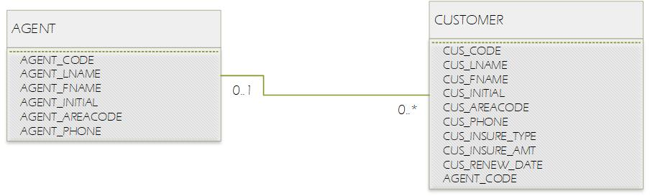

1. Identify each relationship type and write all of the business rules. Each individual store is located in a region. The relationship between region and store is 1:M. A store has several employees. When assuming the employees do not work at more than one store location, the relationship between store and employee is 1:M. A business can have multiple employees with the same job or position title. Again, we are assuming that employees do not have multiple titles. Therefor, the relationship between job and employee is 1:M.
2. Identify each relationship type and write all of the business rules. Similarly to the figure discussed earlier, the relationships are 1:M. One course can have multiple listed classes/sections. The class is an instance of the course. Student is referenced in the enroll table. Every instance of enrollment contains one student. Class is also referenced in the enroll table. Every instance of enrollment contains one class. All classes/sections of enrollment reference a student. A student cannot enroll in the same class more than one time. When a student enrolls in multiple classes they are listed on the enrollment table to match that number.
3. Create the basic Crow’s Foot ERD for Tiny College.

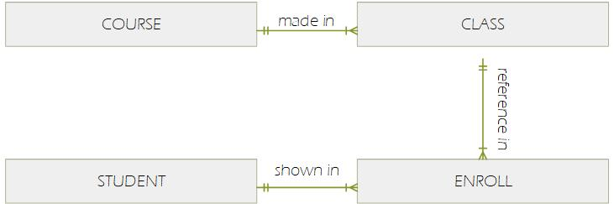

1. 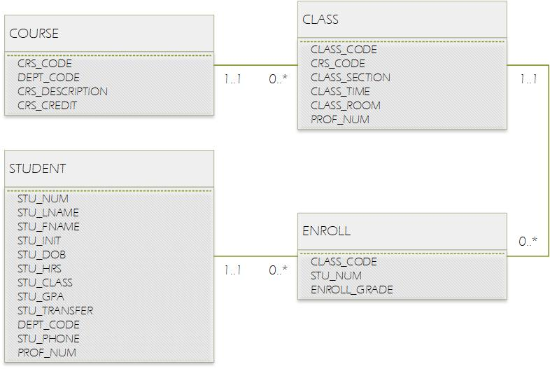Create the UML class diagram that reflects the entities and relationships you identified in the relational diagram.